How AJAX Works
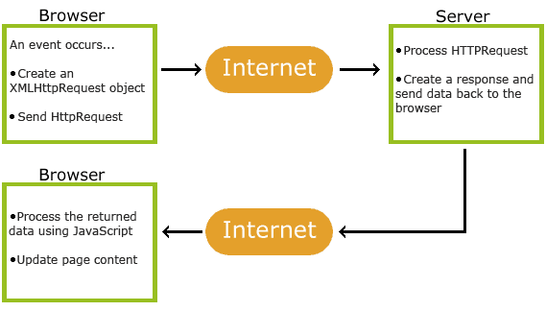
AJAX

1. An event occurs in a web page (the page is loaded, a button is clicked)
2. An XMLHttpRequest object is created by JavaScript
3. The XMLHttpRequest object sends a request to a web server
4. The server processes the request
5. The server sends a response back to the web page
6. The response is read by JavaScript
7. Proper action (like page update) is performed by JavaScript

